DSA Mini Project

**Lift Management System**

***Submitted by***

**Shrinjita Paul [RA2211047010017]**

**Ali Khan [RA2211047010066]**

**Ancy B John [RA2211047010067]**

*Under the Guidance of*

**Dr. Reshmy AK**

**Assistant Professor, CINTEL**

*In partial satisfaction of the requirements for the degree of*

**BACHELOR OF TECHNOLOGY**

**In ARTIFICIAL INTELLIGENCE**



**SCHOOL OF COMPUTING**

**COLLEGE OF ENGINEERING AND TECHNOLOGY**

**SRM INSTITUTE OF SCIENCE AND TECHNOLOGY**

**KATTANKULATHUR – 603203**

**NOVEMBER 2023**



**SRM INSTITUTE OF SCIENCE AND TECHNOLOGY**

**KATTANKULATHUR- 603203**

**(Under Section 3 of UGC Act, 1956)**

**BONAFIDE CERTIFICATE**

Certified that this Course Project Report titled in " **Lift Management System**" is the bonafide work of **Shrinjita Paul [RA2211047010017], Ali Khan [RA2211047010066], Ancy B John [RA2211047010067]** III Sem B. Tech (AI) who carried out the work under my supervision for the course **21CSC201J Data Structures and Algorithms.** Certified further, that to the best of my knowledge, the work reported herein does not form part of any other work.

| **SIGNATURE**  **Faculty In-Charge**  **Dr. Reshmy AK**  Assistant Professor  Department of Computational Intelligence  SRM Institute of Science and Technology  Kattankulathur Campus, Chennai | **SIGNATURE**  **HEAD OF THE DEPARTMENT**  **Dr. R Annie Uthra**  Professor and Head,  Department of Computational Intelligence,  SRM Institute of Science and Technology  Kattankulathur Campus, Chennai |
| --- | --- |

**CONTENT**

| **TOPIC** | **PAGE NO** |
| --- | --- |
| 1. Introduction |  |
| 1. Problem Statement |  |
| 1. Aim |  |
| 1. Role of DSA |  |
| 1. Tech Stack |  |
| 1. Implementation |  |
| 1. Analysis & Future |  |
| 1. Conclusions |  |

**CONTRIBUTION TABLE**

| **TOPIC** | **REG NO** | **CONTRIBUTION** |
| --- | --- | --- |
| 1. Shrinjita Paul | RA2211047010017 | Presentation & Report |
| 1. Ali Khan | RA2211047010066 | Code |
| 1. Ancy B John | RA2211047010067 | Idea & Algorithms |

1. **INTRODUCTION**

In a world where efficiency, safety, and reliability are paramount, our innovative solution emerges as a beacon of progress, aiming to redefine the standards of lift management.

The Lift Management System is a meticulously crafted platform that goes beyond conventional elevator management, offering a comprehensive approach to enhance safety, streamline operations, and elevate overall user experience. With a commitment to excellence, our system embraces cutting-edge technology and strategic design to address the challenges faced in the dynamic realm of vertical transportation.

Safety is at the forefront of our priorities. The Lift Management System incorporates state-of-the-art security features, real-time monitoring, and predictive maintenance capabilities, ensuring that passengers can trust in the system's reliability and dependability. Through advanced sensors and analytics, potential issues can be identified and addressed proactively, minimizing downtime and maximizing safety.

Reliability is the backbone of any successful lift system, and our project is engineered to surpass expectations. By optimizing efficiency through intelligent traffic management and remote diagnostics, the Lift Management System aims to reduce wait times, enhance energy efficiency, and extend the lifespan of elevator components. This commitment to reliability is underscored by a dedication to minimizing disruptions and providing a seamless vertical transportation experience.

Convenience is the hallmark of our project. We understand the importance of a user-friendly interface, and the Lift Management System is designed with the end user in mind. From intuitive control interfaces to personalized settings, our system ensures a smooth and convenient experience for both passengers and operators alike. As we embark on this journey to redefine vertical transportation, the Lift Management System Project stands as a testament to innovation, efficiency, and a commitment to elevating the standards of lift management. Join us in shaping the future of vertical transportation, where safety, reliability, and convenience converge in a harmonious ascent toward excellence.

1. **PROBLEM STATEMENT**

In the realm of vertical transportation, the current challenge lies in addressing the immediate and efficient use of elevators by individuals with reduced mobility, such as those with broken legs. The existing elevator systems often lack the necessary prioritization mechanisms to ensure that individuals facing mobility challenges experience swift and seamless access to elevators. This deficiency in accessibility not only inconveniences those with reduced mobility but also poses potential safety concerns.

The core problem to be addressed by the Lift Management System is the absence of a dedicated and efficient solution to cater to the specific needs of individuals with reduced mobility. The existing systems do not prioritize their access, resulting in extended wait times, difficulties in boarding, and an overall lack of convenience. This issue not only affects the daily lives of those with reduced mobility but also contradicts the principles of inclusivity and accessibility that modern technology should uphold.

Therefore, the primary objective of the Lift Management System Project is to devise a solution that ensures priority access for individuals with reduced mobility, facilitating their immediate and efficient use of elevators.

This priority access should encompass features such as reduced waiting times, strategic elevator allocation, and user-friendly interfaces tailored to the unique needs of this demographic. By doing so, the system aims to enhance overall accessibility, elevate user experience, and contribute to a more inclusive and considerate vertical transportation environment. Through the implementation of this solution, we aspire to bridge the accessibility gap, providing a dignified and streamlined experience for individuals with reduced mobility within the elevator infrastructure.

1. **AIM**

This project seeks to enhance elevator operations in buildings by addressing inefficiencies, delays, and prioritizing medical emergencies, particularly for individuals with conditions like broken limbs.

1. **Role of DSA**

The implementation of Data Structures and Algorithms (DSA) plays a pivotal role in optimizing lift management within the system. By employing a dynamic passenger sorting mechanism through the use of a Priority Queue, the system enhances operational efficiency, ensuring a streamlined and responsive vertical transportation experience.

The Priority Queue, a fundamental data structure in this context, allows for the efficient prioritization of passengers based on their specific needs, such as individuals with reduced mobility. This dynamic sorting mechanism ensures that the elevator system responds promptly to priority requests, minimizing wait times and optimizing the overall flow of passengers. In addition to prioritization, DSA contributes to stringent memory management within the Lift Management System. Efficient memory allocation and deallocation practices are essential for preventing system inefficiencies and potential errors. Through the careful implementation of data structures, memory resources are utilized judiciously, promoting system stability and responsiveness. Furthermore, DSA is integral to input validation practices within the system. By employing algorithms to validate and sanitize user inputs, the system can preemptively identify and address potential issues, contributing to the reliability and safety of the overall lift management process. Validating inputs helps prevent undesired behavior and ensures that the system operates within predefined parameters, reducing the risk of errors or malfunctions.

In summary, the role of Data Structures and Algorithms in the Lift Management System is multi-faceted. It optimizes operational efficiency through dynamic passenger sorting, upholds stringent memory management practices for system stability, and ensures reliable and safe operation through robust input validation mechanisms. Through the strategic integration of DSA principles, the Lift Management System not only aims to redefine vertical transportation but also stands as a testament to the importance of algorithmic efficiency in enhancing the overall performance of complex systems.

1. **TECH STACK**

The Lift Management System leverages a robust tech stack, carefully chosen to ensure efficiency, reliability, and seamless functionality. The core elements of the tech stack include:

1. **C Programming Language:**

- The system is implemented using the C programming language, known for its efficiency and low-level control over system resources.

1. **Standard Libraries:**

- Standard libraries in C, such as `stdio.h` and `stdlib.h`, provide essential functions for input/output operations and dynamic memory allocation, contributing to the overall functionality of the system.

**3. Data Structures:**

- The system employs various data structures to organize and manage information effectively. Notably, the 'node' structure is used to represent elements within the system.

**4. Algorithms:**

- Algorithmic principles are applied for tasks like dynamic passenger sorting, ensuring optimal elevator response times. The system utilizes algorithms to enhance operational efficiency and prioritize passenger requests using a 'priority queue' data structure.

**5. User Interface:**

- A user-friendly interface is a key aspect of the system. While specific details about the user interface are not explicitly mentioned, the tech stack supports the implementation of interfaces tailored to the needs of passengers, including those with reduced mobility.

**6. Memory Management:**

- The system incorporates memory management practices using functions like `malloc()` and `free()`. Efficient memory allocation and deallocation contribute to system stability and prevent memory-related issues.

**7. Input Validation:**

- Input validation is a critical aspect of system reliability. The tech stack includes mechanisms for validating user inputs, ensuring that the system operates within predefined parameters and minimizing the risk of errors.

By combining the power of the C programming language, standard libraries, data structures, algorithms, and memory management practices, the Lift Management System aims to deliver a high-performance solution that prioritizes efficiency, reliability, and user satisfaction within the realm of vertical transportation.

1. **IMPLEMENTATION**

**Enqueuing**

Enqueuing is the process of adding individuals to the lift queue, ensuring an organized and prioritized order. The system employs a priority-based insertion mechanism utilizing the 'enqueue' function. This function is responsible for strategically placing individuals in the queue based on factors such as priority, ensuring that passengers, particularly those with reduced mobility, are appropriately positioned for efficient elevator access.

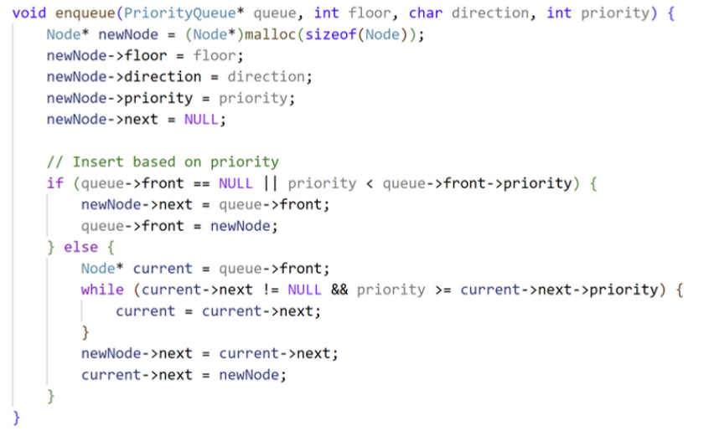

**Dequeue**

Dequeueing involves the removal of individuals from the queue while maintaining the established priority order. The 'dequeue' function is instrumental in this process, systematically extracting passengers from the queue according to their priority status. This ensures that individuals are served in a fair and efficient manner, aligning with the system's commitment to optimized vertical transportation.

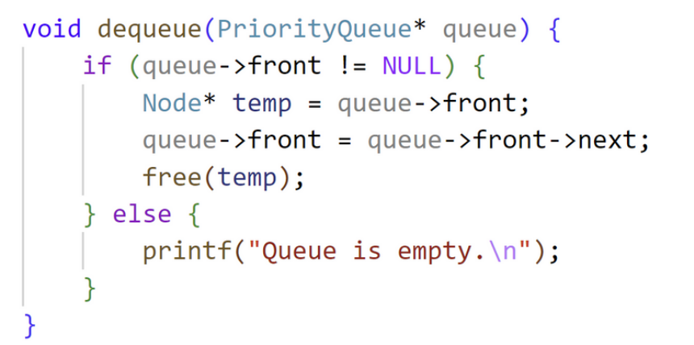

**Display**

The 'displayQueue' function serves as a vital component in offering visibility to users regarding the queue's status. Through this function, the system informs users about the current composition of the queue, highlighting the individuals awaiting elevator access and their respective priority levels. This transparency enhances user experience, contributing to a sense of predictability and understanding of the lift management process.

In summary, the enqueuing process facilitates the organized addition of individuals to the lift queue, leveraging priority-based insertion. Dequeueing ensures the systematic removal of passengers while maintaining prioritization. The display function enhances user visibility by providing real-time information about the queue's status, fostering a user-friendly and efficient lift management experience. Together, these processes contribute to the overarching goal of creating a streamlined, accessible, and reliable vertical transportation system.

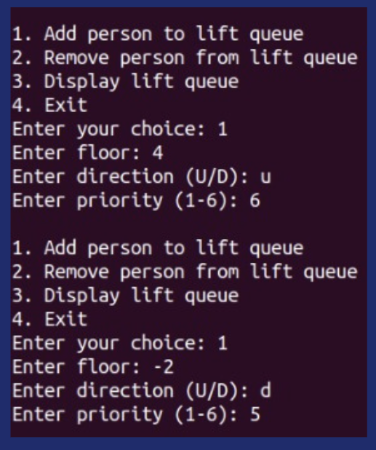

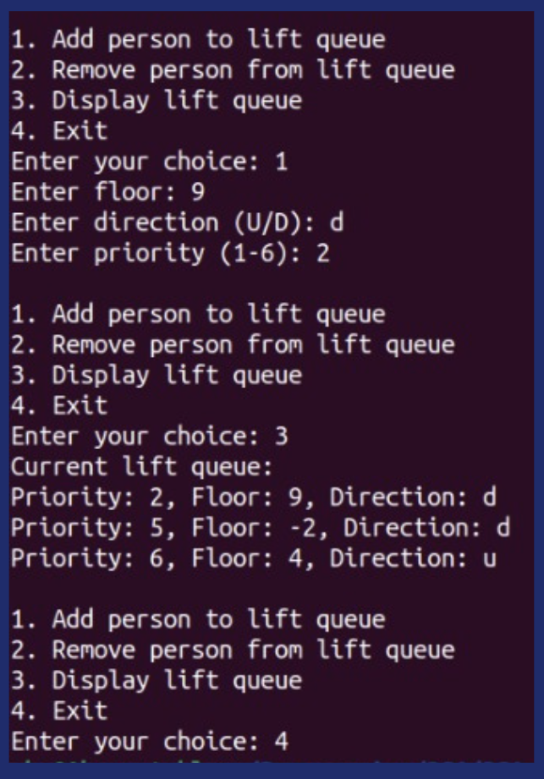

1. **ANALYSIS & FUTURE**

Looking ahead, the Lift Management System aspires to usher in a new era of innovation by incorporating cutting-edge libraries like SimpleCV and CImg. This strategic move aims to disrupt the traditional lift management paradigm and envision a future where autonomous lift systems redefine the passenger experience.

The goal is to eliminate the necessity for a dedicated lift operator at each floor, replacing it with an autonomous lift management system driven by computer vision and image processing capabilities. This bold vision is underpinned by the belief that advanced technologies can enhance safety, efficiency, and overall user satisfaction in vertical transportation.

The envisaged autonomous lift management system seeks to go beyond conventional operations. By leveraging computer vision, lifts can autonomously assess passenger needs, optimize traffic flow, and prioritize individuals based on factors like urgency or mobility requirements. This transformative approach not only promises a safer and more efficient vertical transportation experience but also aligns with the principles of adaptability and sustainability in modern building infrastructure.

The integration of SimpleCV and CImg libraries is a strategic move towards infusing the system with state-of-the-art image processing capabilities. This will empower lifts to interpret and respond to the dynamic environment, enhancing their ability to navigate and serve passengers with precision.

In summary, the future of the Lift Management System is characterized by a commitment to innovation, autonomy, and the integration of cutting-edge technologies. By revolutionizing the traditional lift management paradigm, the system aims to create a seamless, adaptive, and sustainable vertical transportation experience that aligns with the evolving needs of modern buildings and their occupants.

1. **CONCLUSION**

In conclusion, the Lift Management System Project stands at the forefront of innovation in vertical transportation. With a foundation built on the robust C programming language, standard libraries, and essential data structures and algorithms, the system optimizes lift management, prioritizing individuals with reduced mobility through dynamic passenger sorting mechanisms. The inclusion of memory management practices and input validation further ensures system reliability and safety.

Looking ahead, the system's vision extends beyond current capabilities, aiming to leverage cutting-edge libraries such as SimpleCV and CImg to revolutionize the traditional lift management paradigm. Envisioning a future where autonomous lift systems operate through computer vision and image processing, the project strives to eliminate the need for dedicated lift operators, offering a safer and more efficient vertical transportation experience.

The potential integration of these advanced technologies promises not only to enhance operational efficiency but also to contribute to the overall sustainability and adaptability of lift systems in modern buildings. By prioritizing autonomy, safety, and efficiency, the Lift Management System aspires to set new standards in the realm of vertical transportation, creating a user-centric, intelligent, and forward-thinking solution for the future. As we embrace this vision, we embark on a journey to redefine how we move vertically within buildings, fostering a more accessible, responsive, and technologically advanced lift management experience.